Отчёт №1

SPecialiST RePack | [Адрес организации]

Лабораторная работа по моделированию ИУС

Давид Назлуян

2015

Задание №1   
Num1.m Содержание:

%Вариант 16

clc

clf

clear

close all

Eps = 0.01;

T1 = 0.2;

T2 = 0.1;

k = 1;

w = 0.0001:0.01:100;

A_w = k./(sqrt((T1.*w).^2+1));

figure(1)

semilogx(w,A_w,'-r');

hold on; grid on;

xlabel('w');

ylabel('A(w)');

A_w = k./(sqrt((T2.*w).^2)+1);

semilogx(w,A_w,'-blue');

legend('A(w) при Т1','A(w) при Т2');

title('A(w)');

% фи от омЕга

figure;

phi_w = -atan(w.*T1);

semilogx(w,phi_w,'-r');

hold on; grid on;

phi_w = -atan(w.*T2);

semilogx(w,phi_w,'-blue');

legend('phi(w) при Т1','phi(w) при Т2');

title('phi(w)');

grid on;

%U(w)

figure;

U_w = k./((T1.*w).^2+1);

semilogx(w,U_w,'-r');

hold on; grid on;

U_w = k./((T2.*w).^2+1);

semilogx(w,U_w,'-blue');

xlabel('w');

ylabel('U(w)');

legend('U(w) при Т1','T(w) при Т2');

title('T(w)');

%V(w)

figure;

V_w = -k*T1.*w./((T1.*w).^2+1);

semilogx(w,V_w,'-r');

hold on; grid on;

V_w = -k*T1.*w./((T2.*w).^2+1);

semilogx(w,V_w,'-blue');

legend('V(w) при Т1','V(w) при Т2');

title('V(w)');

%L(w)

figure;

L_w = 20*log(k)-20*log10(sqrt((T1.*w).^2+1));

semilogx(w,L_w,'-r');

hold on; grid on;

L_w = 20*log(k)-20*log10(sqrt((T2.*w).^2+1));

semilogx(w,L_w,'-blue');

legend('L(w) при Т1','L(w) при Т2');

title('L(w)');

w = 0:0.1:5;

y = zeros(1,51);

semilogx(w,y,'-cyan');

w = 5:0.1:100;

y = 20*log10(k)-20*log10(T1*w);

semilogx(w,y,'-cyan');

sys = tf(k,[T1 2]);

ltiview(sys)

grid;

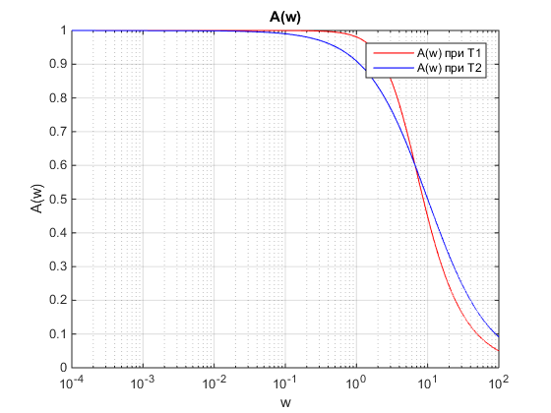

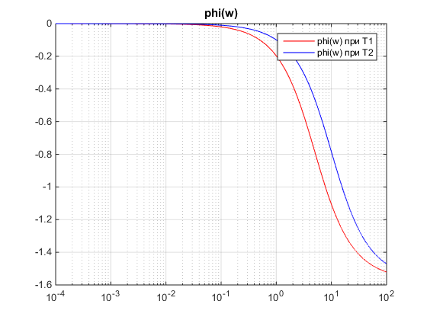

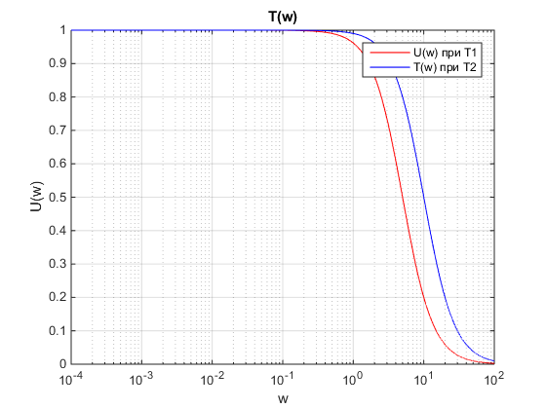

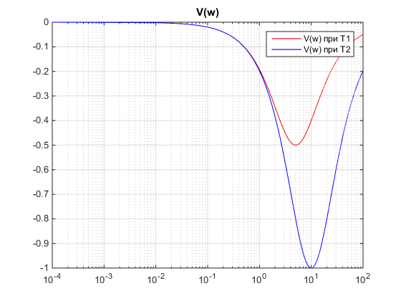

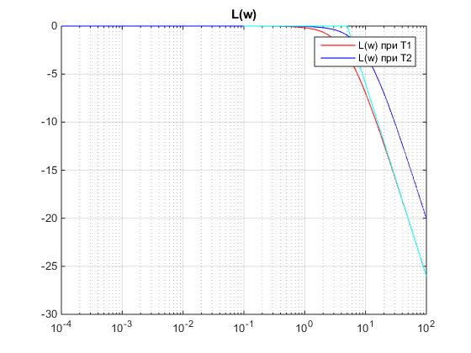

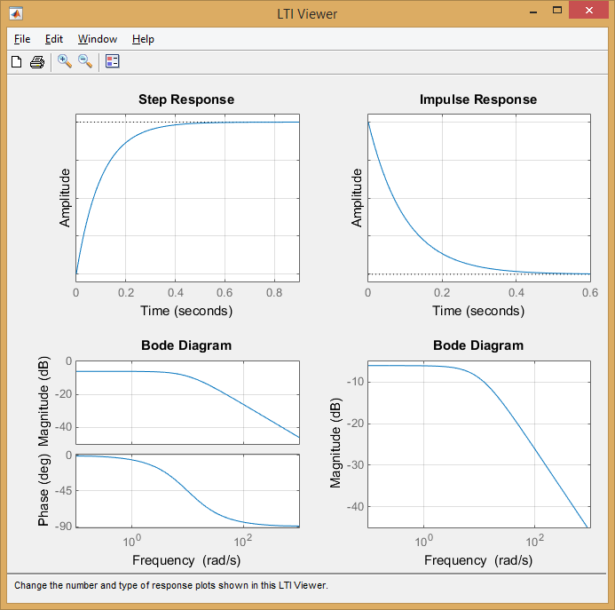

Задание №2  
Num2.m Содержание:

%%

%Вариант 16

clc

clf

clear

close all

epsil = 0.01;

pii = 3.14;

T1 = 0.2;

T2 = 0.1;

k = 1;

w = 0.01:0.01:100;

A = w.^2;

B = (T1^2);

C = 1 - A.*B;

D = 2.*epsil.*T1.*w;

E = D.^2;

F = C.^2;

A_w = k./( sqrt( ((1-(T1.^2).*(w.^2)).^2) + ((2*epsil*T1*w).^2) ) );

figure

semilogx(w,A_w,'-r');

hold on; grid on;

xlabel('w');

ylabel('A(w)');

A_w = k./(sqrt((1-(T2).^2.*(w).^2).^2+ (2.*epsil.*T2.*w).^2));

semilogx(w,A_w,'-blue');

legend('A(w) при Т1','A(w) при Т2');

title('A(w)');

% фи от омЕга

figure;

w1 = 0.01:0.01:9.99;

w2 = 10.01:0.01:100;

phi_w = -acot((2.*epsil.*T1.*w1)./(1-(T1.^2).*(w1.^2)));

semilogx(w1,phi_w,'-r');

hold on; grid on;

phi_w = -acot((2.*epsil.*T1.*w2)./(1-(T1.^2).*(w2.^2)));

semilogx(w2,phi_w,'-r');

w1 = 0.01:0.01:19.99;

w2 = 20.01:0.01:100;

phi_w = -acot((2.*epsil.*T2.*w1)./(1-(T2.^2).*(w1.^2)));

semilogx(w1,phi_w,'-blue');

phi_w = -acot((2.*epsil.*T2.*w2)./(1-(T2.^2).*(w2.^2)));

semilogx(w2,phi_w,'-blue');

legend('phi(w) при Т1','','phi(w) при Т2','');

title('phi(w)');

xlabel('w');

ylabel('phi(w)');

grid on;

%U(w)

figure;

U_w = (k.*(1-(T1).^2.*(w).^2))./((1-(T1).^2.*(w).^2).^2+ (2.*epsil.*T1.*w).^2);

semilogx(w,U_w,'-r');

hold on; grid on;

U_w = (k.*(1-(T2).^2.*(w).^2))./((1-(T2).^2.*(w).^2).^2+ (2.*epsil.*T2.*w).^2);

semilogx(w,U_w,'-blue');

xlabel('w');

ylabel('U(w)');

legend('U(w) при Т1','T(w) при Т2');

title('T(w)');

%V(w)

figure;

V_w = -2*k*epsil*T1.*w./((1-(T1).^2.*(w).^2).^2+ (2.*epsil.*T1.*w).^2);

semilogx(w,V_w,'-r');

hold on; grid on;

V_w = -2*k*epsil*T2.*w./((1-(T2).^2.*(w).^2).^2+ (2.*epsil.*T2.*w).^2);

semilogx(w,V_w,'-blue');

legend('V(w) при Т1','V(w) при Т2');

title('V(w)');

xlabel('w');

ylabel('V(w)');

%L(w)

figure;

L_w = 20*log10(k)- 20*log10((1-(T1).^2.*(w).^2).^2+ (2.*epsil.*T1.*w).^2);

semilogx(w,L_w,'-r');

hold on; grid on;

L_w = 20*log10(k)- 20*log10((1-(T2).^2.*(w).^2).^2+ (2.*epsil.*T2.*w).^2);

semilogx(w,L_w,'-blue');

legend('L(w) при Т1','L(w) при Т2');

xlabel('w');

ylabel('L(w)');

title('L(w)');

w = 0:0.1:5;

y = zeros(1,51);

semilogx(w,y,'-cyan');

w = 5:0.1:100;

y = 20*log10(k)-80*log10(T1*w);

semilogx(w,y,'-cyan');

sys = tf(k,[T1 2]);

ltiview(sys)

grid;

